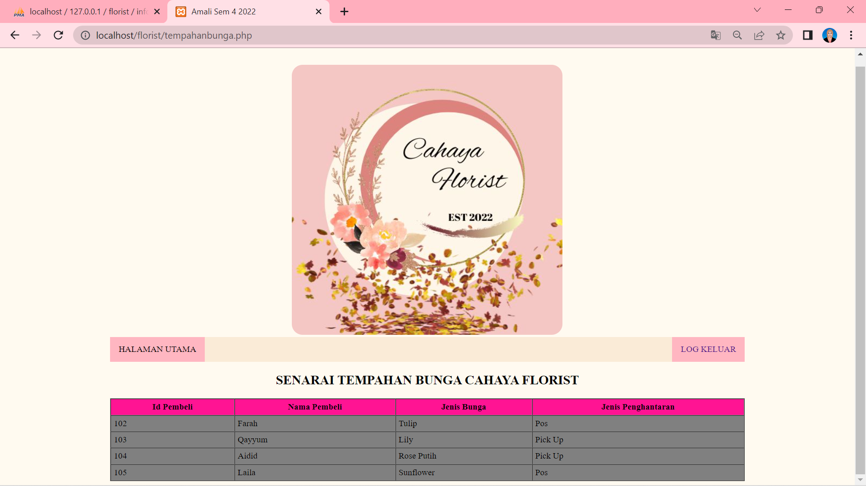

index.php

<?php
include 'config.php';
//Ralat sambungan pangkalan data
$error='';
if(isset($_POST['submit'])){
if(empty($_POST['username']) || empty($_POST['password'])){
$error = "Username or Password is Invalid";
}
else
{
$username=$_POST['username'];
$password=$_POST['password'];
$query = mysqli_query($connect, "SELECT * FROM user WHERE password='$password' AND username='$username'");
//Ralat nama jadual user
//Ralat sintaks semicolon
$rows = mysqli_num_rows($query);
if($rows == 1){
header("Location: tempahanbunga.php");
//Ralat nama pautan fail
}
else
{
$error = "Username of Password is Invalid";
}}}

?>
config.php

<?php //Ralat pada sintaks PHP
$connect = mysqli_connect('localhost', 'root', '123456', 'florist') or die('Failed to connect to db.') ;
//Ralat password
//Ralat nama pangkalan data
?>

tempahanbunga.php

</style>
<body>
<br><br>
<div style="width: 75%; margin: 0 auto; text-align: center; "><img src="logoflorist.jpg" style="border-radius: 20px;"></div> <!--Ralat format imej-->
----------------------------------------------------------------------------------------------------------------------------
<div style=" background-color: antiquewhite; color: black; width: 75%; margin: 0 auto;">
<a>HALAMAN UTAMA</a>
<a href="index.php" style="float: right;">LOG KELUAR</a> //Ralat pautan navigation bar
----------------------------------------------------------------------------------------------------------------------------
</div>
<h2 style="text-align: center;">SENARAI TEMPAHAN BUNGA CAHAYA FLORIST</h2>
//Ralat ejaan CAHAYA
<table border="1" cellpadding="5" cellspacing="0" bgcolor="grey">
<tr>
<th>Id Pembeli</th>
<th>Nama Pembeli</th>
<th>Jenis Bunga</th>
//Ralat ejaan BUNGA
<th>Jenis Penghantaran</th>
</tr>
----------------------------------------------------------------------------------------------------------------------------

<?php
include 'config.php';
$result = mysqli_query($connect,"SELECT * FROM infobunga ")
//Ralat tidak memanggil nama jadual yang betul
or die(mysqli_error());
while ($res=mysqli_fetch_array($result))
{
echo "<tr>
<td>".$res['idpembeli']."</td>
<td>". $res['namapembeli'] ."</td>
<td>". $res['jenisbunga'] ."</td>
<td>". $res['jenispenghantaran'] ."</td>
</tr>";
}
?>

